|  |
| --- |
| 鼓励自己的话：  **番茄工作每日计划表** |
|
|
|  |

|  |  |  |  |  |  |  |  |  |  |  |
| --- | --- | --- | --- | --- | --- | --- | --- | --- | --- | --- |
| 优先级 | 任务 | 番茄数 |  | 优先级 | 任务 | 番茄数 |  | 优先级 | 任务 | 番茄数 |
|  |  |  |  |  |  |  |  |  |  |  |
|  |  |  |  |  |  |  |  |  |  |  |
|  |  |  |  |  |  |  |  |  |  |  |
|  |  |  |  |  |  |  |  |  |  |  |
|  |  |  |  |  |  |  |  |  |  |  |
|  |  |  |  |  |  |  |  |  |  |  |
|  |  |  |  |  |  |  |  |  |  |  |

|  |  |  |  |  |  |  |  |  |  |  |
| --- | --- | --- | --- | --- | --- | --- | --- | --- | --- | --- |
| 优先级 | 任务 | 番茄数 |  | 优先级 | 任务 | 番茄数 |  | 优先级 | 任务 | 番茄数 |
|  |  |  |  |  |  |  |  |  |  |  |
|  |  |  |  |  |  |  |  |  |  |  |
|  |  |  |  |  |  |  |  |  |  |  |
|  |  |  |  |  |  |  |  |  |  |  |
|  |  |  |  |  |  |  |  |  |  |  |
|  |  |  |  |  |  |  |  |  |  |  |
|  |  |  |  |  |  |  |  |  |  |  |

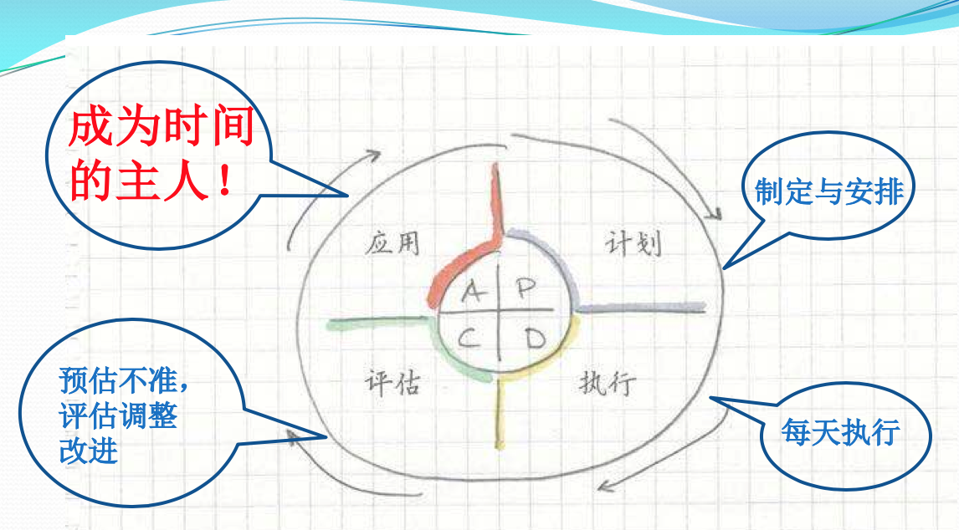姓名： 监督人：

备注：制定与安排任务要优先排序、预估时间、劳逸结合，关键是坚持每天执行，执行过程中若出现预估不准的情况，要重新评估、适当调整。吃掉”番茄时间”，成为时间的主人，你一定可以的！